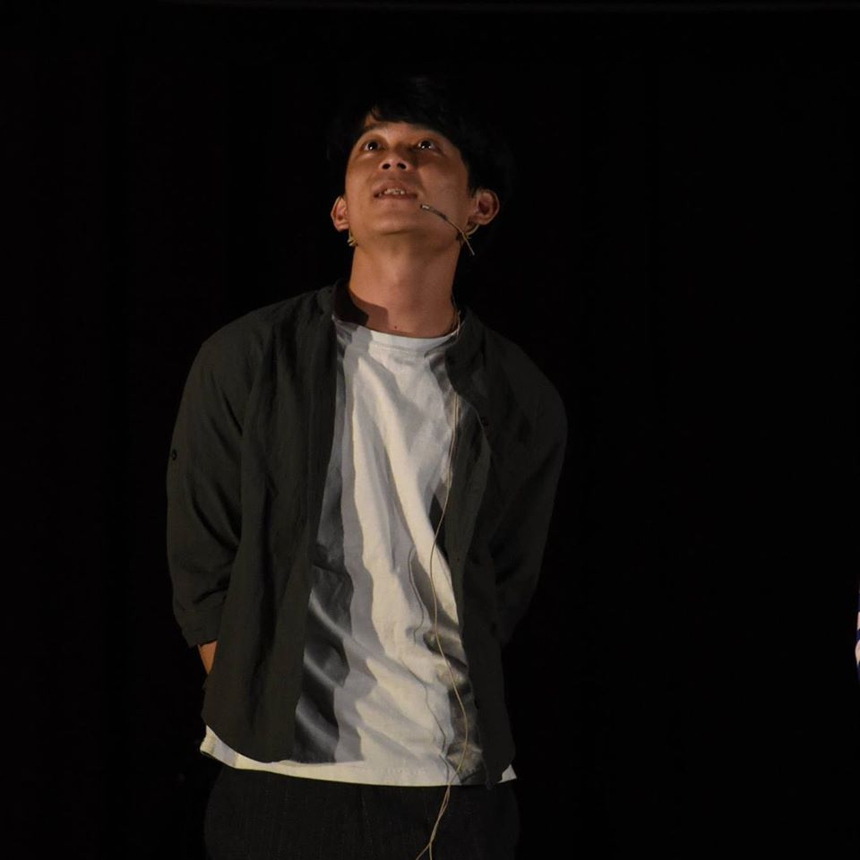

name: Bo-Hao Huang

Received Bachelor Degree in the Department of Computer Science from National Chiao Tung University in Hsinchu, Taiwan in 2019,he is familiar with programming language such as C/C++,and also has the experience of IoT and VR.His research interest targets on Machine Learning algorithm and implement.

**z3588191@gmail.com**